BUILDING A .NET CORE APPLICATION WITH MIDDLEWARE

1. Introduction
This project demonstrates the development of a basic ASP.NET Core web application that uses middleware to handle HTTP requests and responses. The application also serves static files (HTML, CSS, JavaScript) and applies basic security measures such as HTTPS enforcement and Content Security Policy (CSP).

2. Technologies Used
• C#
• ASP.NET Core
• .NET 8
• Visual Studio

3. Project Structure
MiddlewareDemo
├── Program.cs
├── wwwroot
│ ├── index.html
│ ├── style.css
│ ├── script.js
│ └── error.html
└── appsettings.json
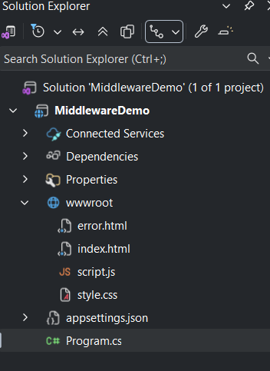

4. Middleware Implementation

4.1 Logging Middleware
A custom middleware component is used to log incoming HTTP requests and outgoing response status codes.
app.Use(async (context, next) =>
{
Console.WriteLine($"Request: {context.Request.Method} {context.Request.Path}");
await next();
Console.WriteLine($"Response Status Code: {context.Response.StatusCode}");
});
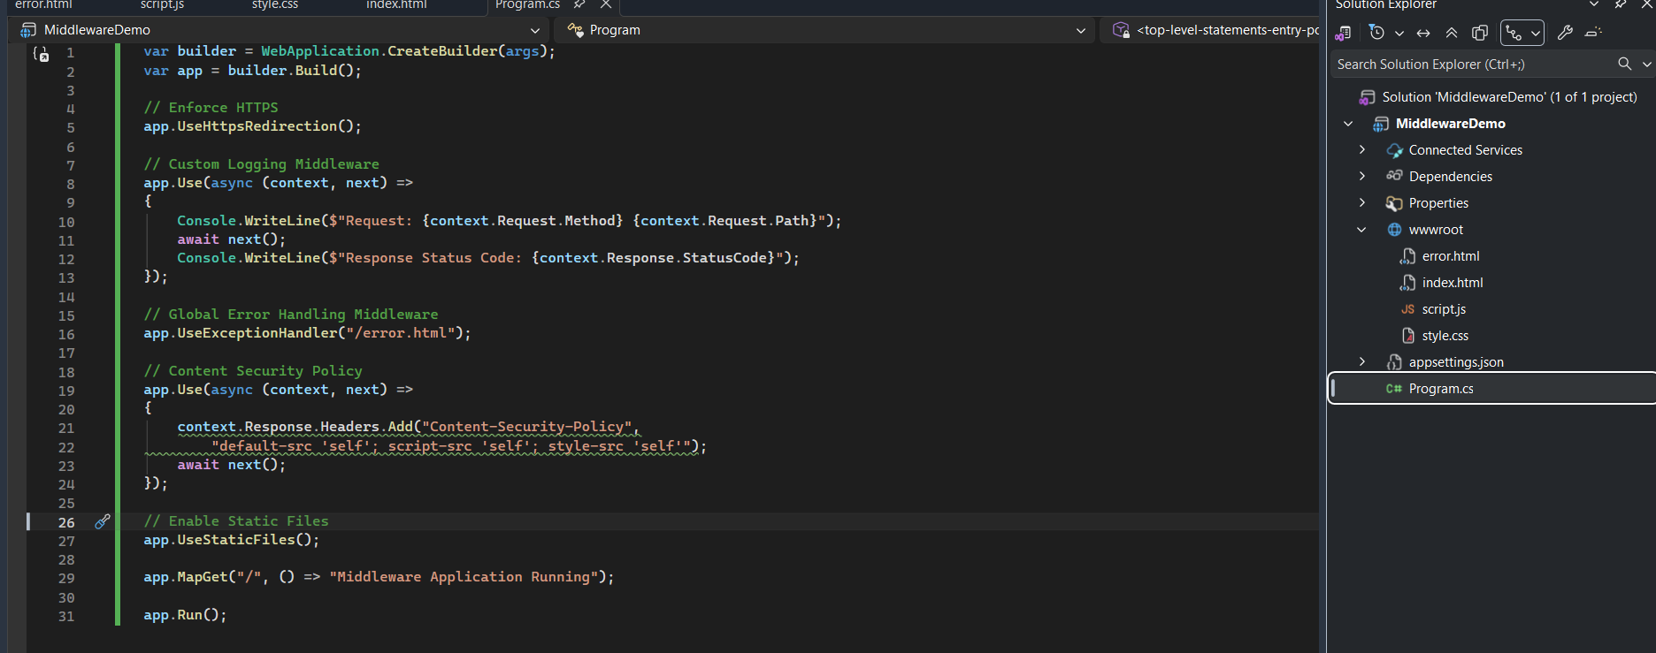

4.2 Error Handling Middleware
The UseExceptionHandler middleware is configured to redirect unhandled exceptions to a custom error page.
app.UseExceptionHandler("/error.html");
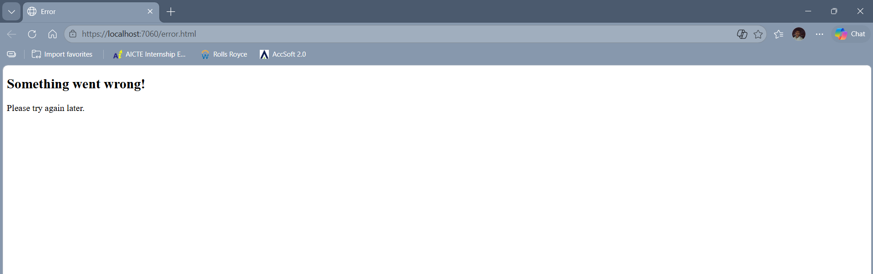

5. Serving Static Files
The application serves static files from the wwwroot folder using UseStaticFiles(). The folder contains index.html, style.css, and script.js.
app.UseStaticFiles();
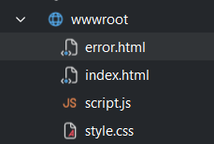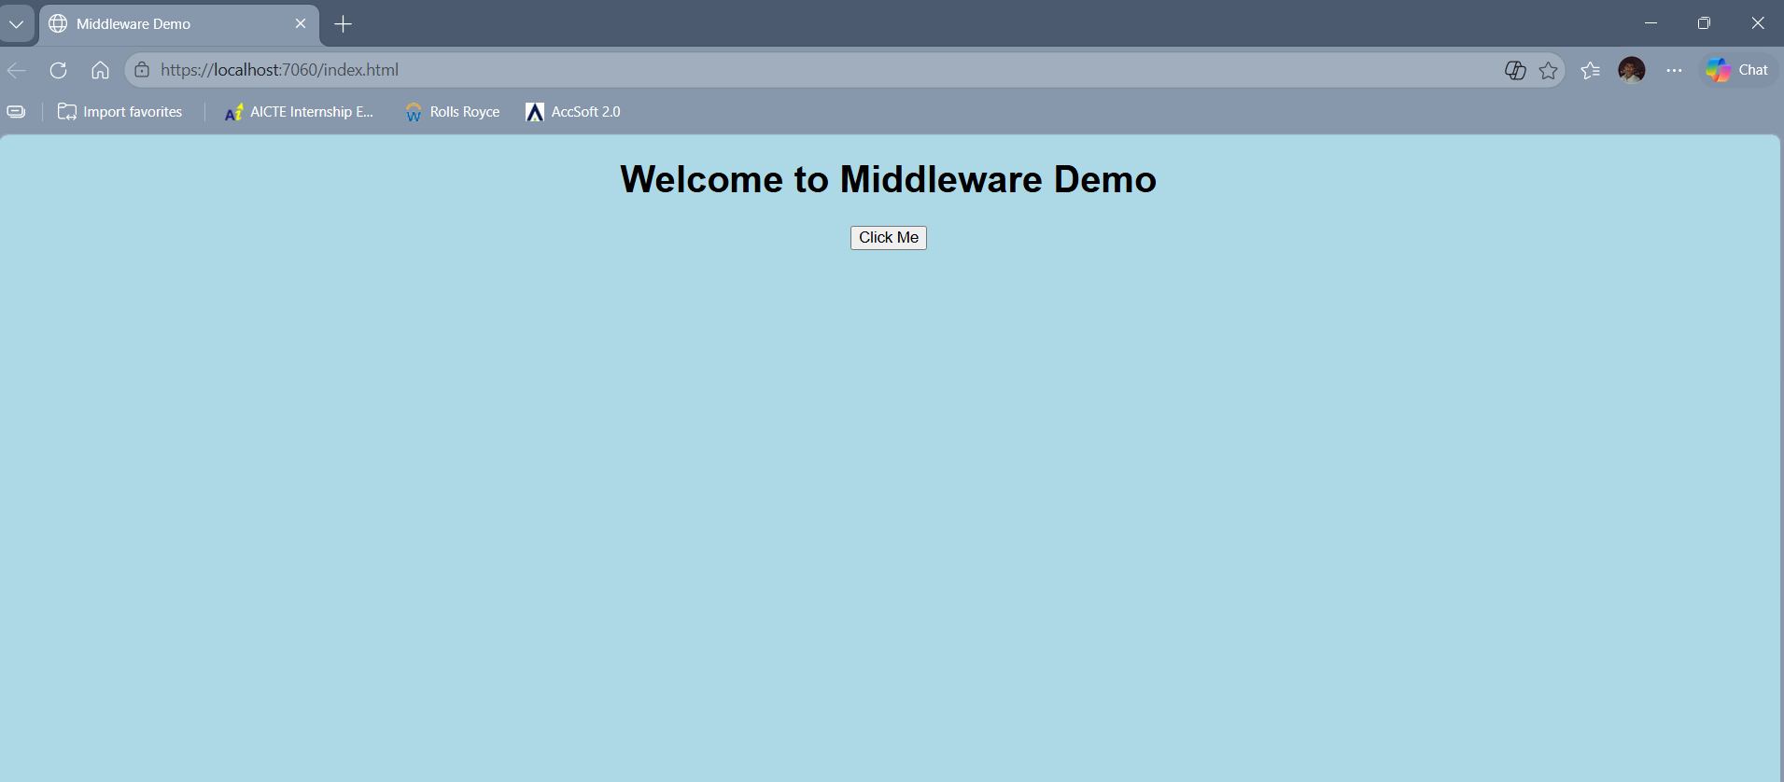

6. Security Implementation

6.1 HTTPS Enforcement
HTTPS redirection is enabled to ensure secure communication.
app.UseHttpsRedirection();

6.2 Content Security Policy (CSP)
A Content Security Policy header is added to prevent security risks such as XSS attacks.
context.Response.Headers.Add("Content-Security-Policy",
"default-src 'self'; script-src 'self'; style-src 'self'");
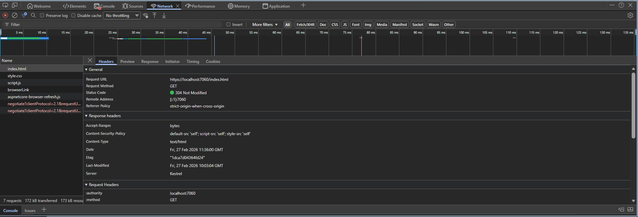

7. Testing
The application was tested to ensure middleware logs requests and responses correctly, static files are served properly, HTTPS is enforced, and the Content Security Policy header is applied.
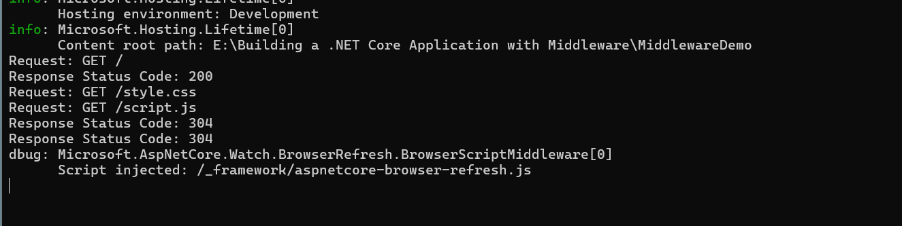

8. Conclusion
This project demonstrates understanding of ASP.NET Core middleware, HTTP request handling, static file serving, and implementation of basic web security measures. All assignment requirements have been successfully implemented.

